“The Value of Advice Tree”
There are many areas in which financial advisers add value to their clients. We have broken them down into three branches, with several individual elements on each branch.
- Money – portfolio, investment and risk management value
- Goals – financial, protection and planning value
- Confidence – trust, coaching and wellbeing value
We have outlined a little more detail about each element and for some of them we have quantified the value in money terms:
Managing your money branch
- Sequence of return risk mitigation – there is a pernicious risk that few investors are aware of. It can have a massive impact on how long your pension fund will last – in the worst case it could reduce your income by nine years or more. We can help you plan and take the simple but effective steps to mitigate that risk – and give you a “longer lasting retirement income”.
- Investment due diligence – we conduct rigorous due diligence on all your investments. We research all the funds and products that we use. With over 9000 instruments in the UK we save your time while giving you peace of mind. Few investors are aware of a feature called pre-funding. We look at the most efficient platforms to hold your investments to make sure that tax refunds and time delays are minimised. This could save you many £s over the years.
- Portfolio management and rebalancing - We use sophisticated modelling tools to try to maximise your return for a given level of risk / risk tolerance. We are seeking better potential performance without the downside. We also keep your portfolio up to date. A portfolio today is very different to one ten years ago and ten years before that – we keep up to date with developments and lower cost solutions.

- Investment and platform cost savings - Reducing costs and boosting efficiency can compound up to big differences over the years. We have access to portfolios that cost from 0.4% per year versus the average managed fund of 1.37% per year (source: Money Management). Wrap platforms can add real value and make portfolio management easier – we make sure we select one that meets your needs. We make sure the platform is cost effective and reliable – making your life easier.
- Diversification – “don’t put all your eggs in one basket”. A well-diversified portfolio can deliver the returns that you seek with a lower amount of risk. We use sophisticated tools to help you achieve the returns you need; within the risk tolerance you have.
- Tax efficiency – We make sure that we use all applicable tax reliefs and allowances each year – thus helping your money grow faster. Estimates suggest that this could boost returns by 1% per year – so on a £100,000 investment that would be £1,000 per year,
- Risk assessment - risk is a complex subject with many dimensions – we will help you navigate and understand risk to ensure the solutions we recommend meet your needs. We use our expertise, structured questions and a conversation to guide you to a solution that meets your needs and objectives in a way you understand.
Achieving your goals branch
- Pensions freedoms – the freedom to draw your pension benefits was introduced in 2015, initially they were trumpeted as offering great choice for consumers. But over time it has become clear that planning and managing income from a pension pot, that may have to last 35 years or more is far more complex than initially thought. Understanding sequence risk and asset class returns vs inflation; establishing a sustainable withdrawal rate; managing life and health longevity; and planning cashflow over four decades is well beyond most investors – especially as they move into later life.
- Intergenerational and charity planning – student debt and rising house prices have put huge pressures on the next generation. It is little surprise that parents and grandparents want to help. But what are the most effective and secure routes. How do you gift but retain family control? What are the tax implications of gifts or house purchase? We can help with all these questions to provide confidence and value you seek.
The Value of Advice Tree
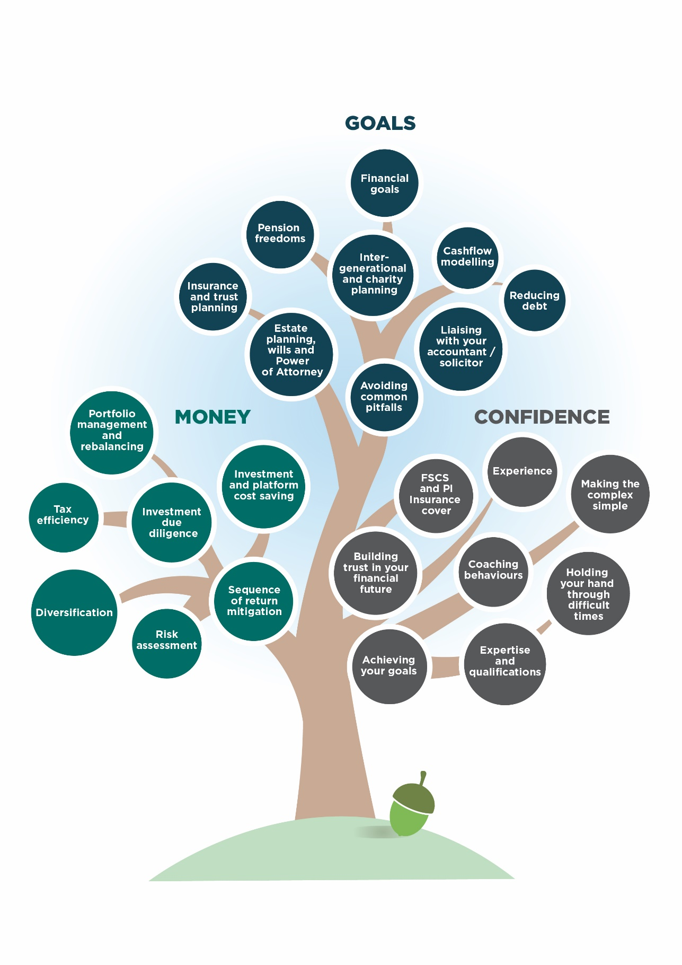
“Providing Confidence in your Financial Future”
- Estate planning, wills and Power of Attorney – managing the transition of wealth from one generation to the next is a complex area. We have many years’ experience in this area and work closely with other professionals. We can help simplify the issues, meet your needs and give you the long-term certainty and flexibility you seek.
- Reducing debt – many people try to save while at the same time have credit card or other expensive debt. We can help build a short-term plan / budget that combines reducing debt, building rainy day savings and looking to the future. For example, we can look at current life cover arrangements with a view to saving money, we can look at pension plans with a view to reducing costs. And we can look at your current savings and ISAs to see if there is not a more efficient and cost-effective way to organise your savings.
- Avoiding common pitfalls - sticking to a plan can be hard when markets are up or down substantially – and humans are proven to be poor at making good decisions. Our process is designed to help manage the best way through these times. Research shows that investors may be losing up to 2% per year by falling into common traps – we assist in avoiding these.
- Insurance and trust planning – using trusts, wills, and other strategies we can make sure your money ends up in the hands of the people you want when you want. Poor planning can see up to 40% of your hard-earned savings or life assurance paid to the tax man. This gives you confidence that your wishes are met, your loved ones protected, and / or your business secured.
- Financial goals – when Alice (in Alice in Wonderland) asks the Cheshire Cat, “Would you tell me, please which way I ought to go from here?” the Cat replies, “That depends a good deal on where you want to get to”. It is the same for all of us – the first stage in achieving your long-term financial goals is to have clarity of what they are. This is a key area of our expertise, and we can help discuss, plan and agree a detailed and realistic plan for your financial future.
- Cashflow modelling - people find it hard (or impossible) to project returns, costs, inflation and their income needs into the future – we use powerful but simple tools that will illustrate this for you. Seeing a picture of your future “money in and out” can really put into perspective how your plan is progressing.
- Liaising with your accountant / solicitor - our experience of working with accountancy and solicitors’ practices gives a great knowledge of tax and legal matters – both personal and corporate. Having clear and joined up plans is more effective and gives you great peace of mind.
Giving you confidence branch
- FSCS and PI Insurance cover – we can look at how best to maximise your protection under the Financial Services Compensation scheme (FSCs) – so your investments are “safer”.
- Our Experience – we have many years of experience in dealing with the ups and downs of financial life – we are here for you when you retire or receive a windfall. We can help with a business sale, planning a legacy or receiving an inheritance. It’s good to be able to talk to someone who has been through it before – that’s what we are here for.
- Coaching behaviours – humans have evolved to survive over many thousands of years. Unfortunately, we have also learned some bad habits and biases in the process. Many of them we are not even aware of. We buy high and sell low, we value the near term more than the short term, we hold onto investments that have fallen, we believe information that reinforces our own views. Part of our role is to act as a coach – helping you avoid these mistakes and guide you to a better future.
- Holding your hand through difficult times - divorce, death, redundancy and making wills are all stressful times. We have experience and expertise and understanding to assist and guide you through them. We are there when you need us most.
- Expertise and qualifications – we have built our expertise over many years. We are fully qualified financial advisers. We are regulated by the Financial Conduct Authority (FCA). We have a Statement of Professional Standing (SPS) issued by an independent professional standards body. And we are required to maintain minimum standards and conduct regular Continuing Professional Development (CPD). Keeping up to date with all financial matters allows us to give you the best possible advice.
- Achieving your goals – we help work out and achieve your financial goals. We ask you questions in a relaxed but structured way; we help you understand risks and opportunities and we build a clear plan for your future. Without a long-term plan your finances are unlikely to head in the right direction. Our job is to give you confidence in the future.
- Making the complex simple - while we are experienced and well qualified, we never forget whose money we are looking after. The simpler we can make your plan the more likely you are to stick to it – and that’s a key measure of our success. We also help reduce your paperwork - we will help you understand what you need to file, will manage application forms and service enquires, provide valuations and updates. We make sure you keep the important things and bin the spam!
- Building trust in your financial future – we can spot opportunities - understanding your objectives allows us to be alert to opportunities – new products, new tax freedoms, better strategies. We are your eyes and ears in the ever-changing tax, legal and product markets. And we will keep you on track - once we have established your risk profile we manage and review your investments to make sure you stay on track over the months and years. We assess your risk profile regularly and the risk of your portfolio to make sure they are in tune.

Here are three independent sources of evidence of the Value of Advice:
- A report by the International Longevity Centre (ILC) think-tank has found that those who have sought professional financial advice are better off by an average of £47,000 over a decade compared to those who did not take advice.

- Research carried out by Unbiased highlights boost to pension pots that professional advice can bring. They state that those taking advice will save an average of £98 per month more, which equates to an additional £3,654 per annum in retirement income, based upon a pension pot of £100,000.

- Analysis shows five areas of financial advice that could each be worth over £14,000 over a ten-year period, for a client with £150,000 invested:
  - Avoiding the behaviour gap: £2800 a year
  - Tax savings: £1770 a year
  - Avoiding sequence losses: £2700 a year (over 20 years)
  - Returns over inflation: £2970 a year
  - Lower investment costs: £1455 a year

